PreclinicalEEGFramework Validation

data source: http://physionet.incor.usp.br/physiobank/database/sleep-edf/
SC4102e0.rec as edf
4/18/1989 3:56 PM
4/19/1989 3:45 PM
23h 49m

NSB EDF Reader.
- fixed error in read. only reading the 1st data record
- fixed subtract out mean
- validated 21Feb2012 as the same read as NeuroScore and Spike2

data source: Maccine
3747
2/9/2012 3:15 AM
2/10/2012 3:00 AM

NSB DSI Reader
- fixed scaling issue
- validated 21Feb2012 as the same read as NeuroScore

NSB_ArtifactDetection

NSB_SpectralAnalysis
data source: SC4102e0.rec

Neuroexplorer: FFT1024, 10 seconds, Hann, 0.488 Hz Bins
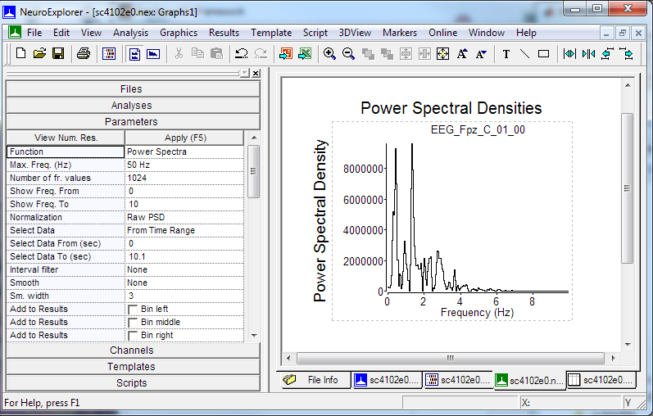

Neuroexplorer: FFT512, 10 seconds, Hann, 0.976 Hz Bins
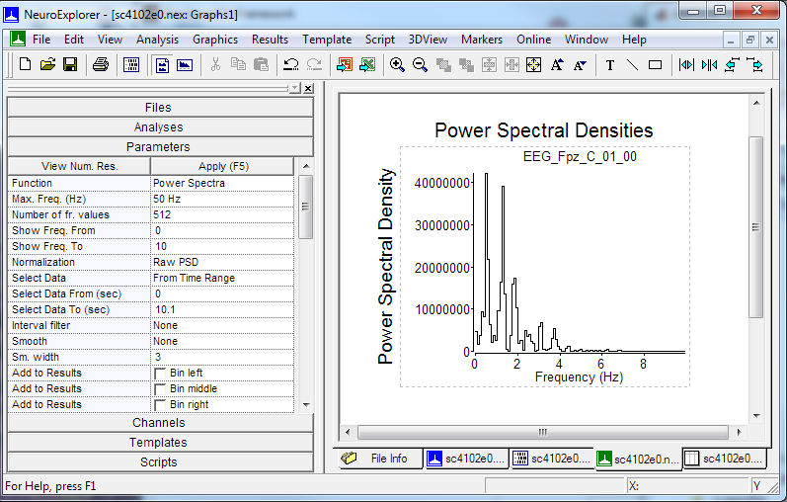

Spike6: FFT1024, 10.24 seconds, Hamming, 0.976 Hz Bins
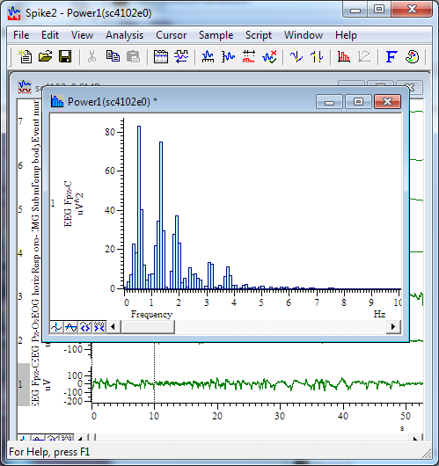

NeuroScore: Generic FFT
FFT1024, 10.24 seconds, Hamming, 0.976 Hz Bins
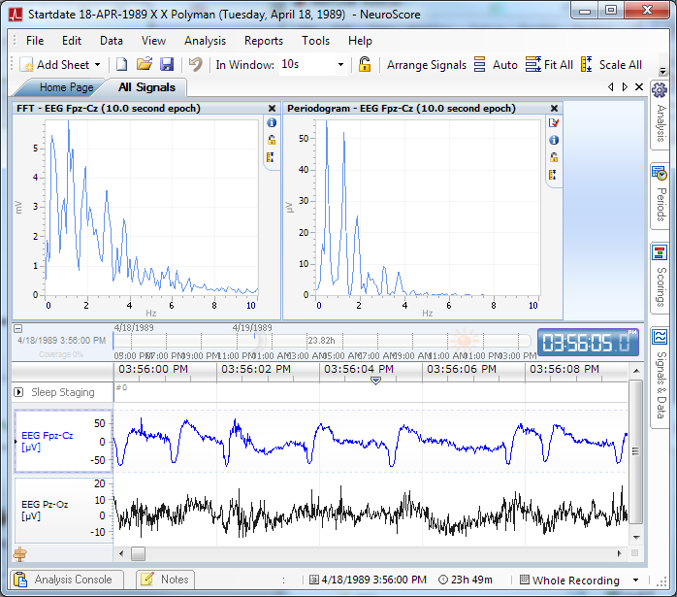

Matlab:
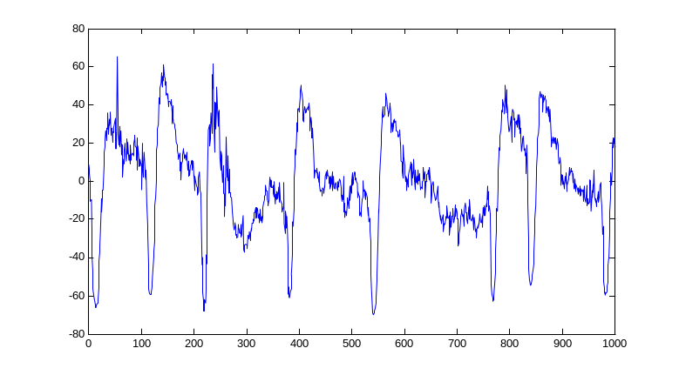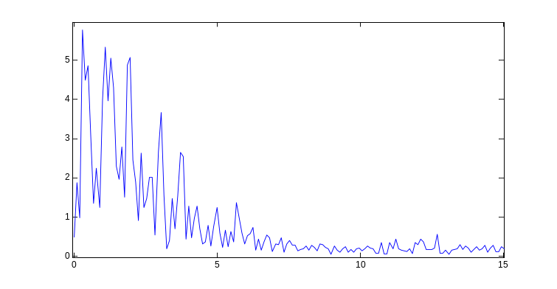

Convolve with Hanning Window
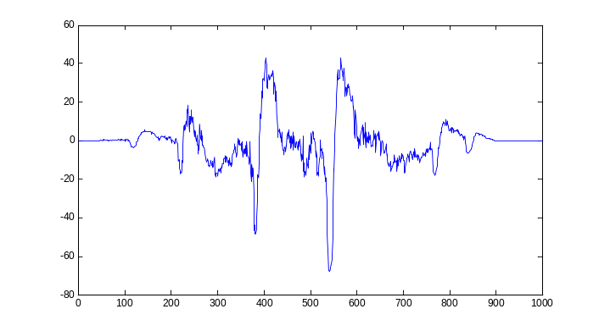

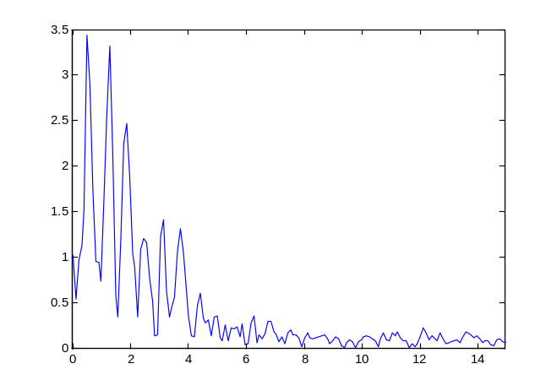
http://faculty.olin.edu/bstorey/Notes/Fourier.pdf
Best Matches Neuroscore
% DFT = abs(fft(BinnedData,nfft))/(nfft/2); %Generate the absolute value of the FFT and scale by half of the sample length
% if (mod(nfft,2)==0) %could use rem here as well since mod 2 always determines odd vs even
% DFT = DFT(1:(nfft/2+1)); %take only the positve frequency half
% else
% DFT = DFT(1:(nfft+1)/2);
% end
% Pyy = DFT.^2;

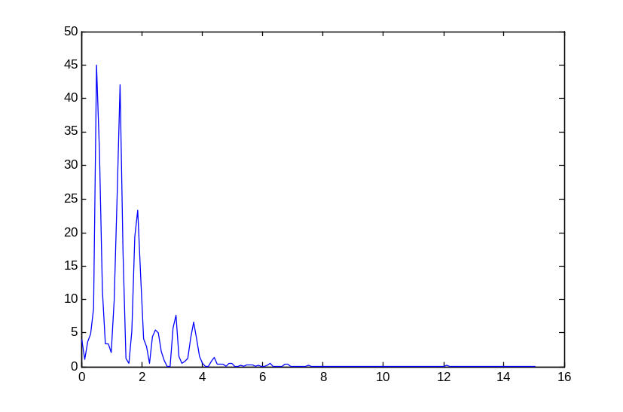

NSB_SaveSpectralData

Load SC4102e0.rec as edf into NeuroScore 2.1
data source http://physionet.incor.usp.br/physiobank/database/sleep-edf/
Used Spectrum Export Wizard
Fpz-Cz

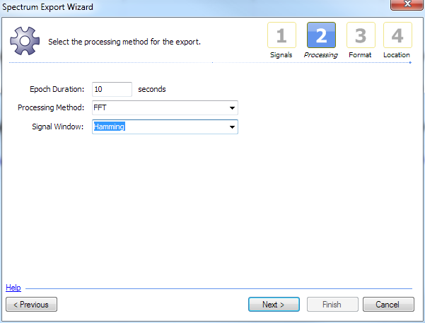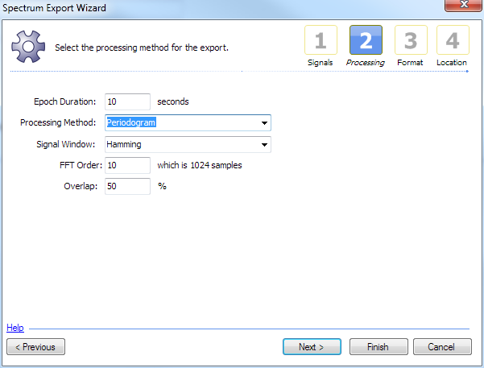
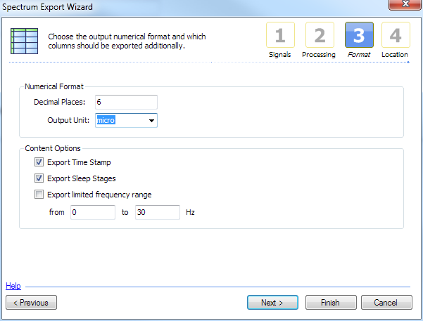

CED using waterfall script
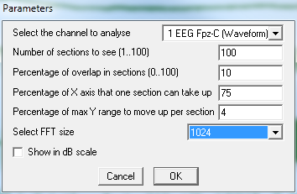
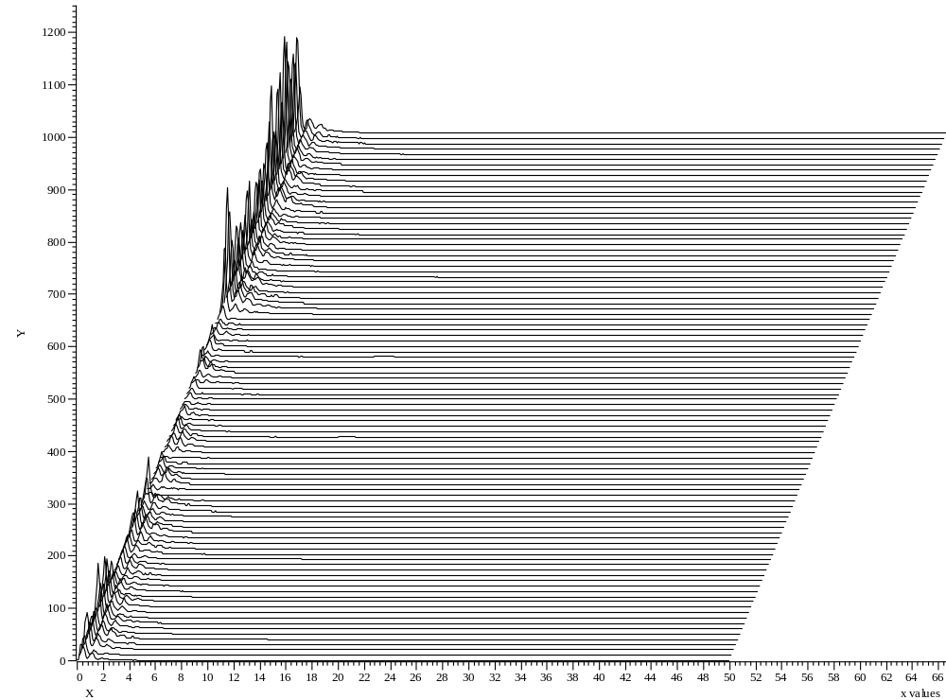

Sleep Scoring Rodent
